بسمه تعالی



پروژه طراحی پایگاه داده‌ها

فاز سوم

استاد

دکتر امینی

پارسا محمدیان ۹۸۱۰۲۲۸۴

سارا آذرنوش ۹۸۱۷۰۶۶۸

ارشان دلیلی 98105751

دامنه‌های صفات

در زیر جدول‌های به دست آمده در فاز ۲ را مشاهده می‌کنید.

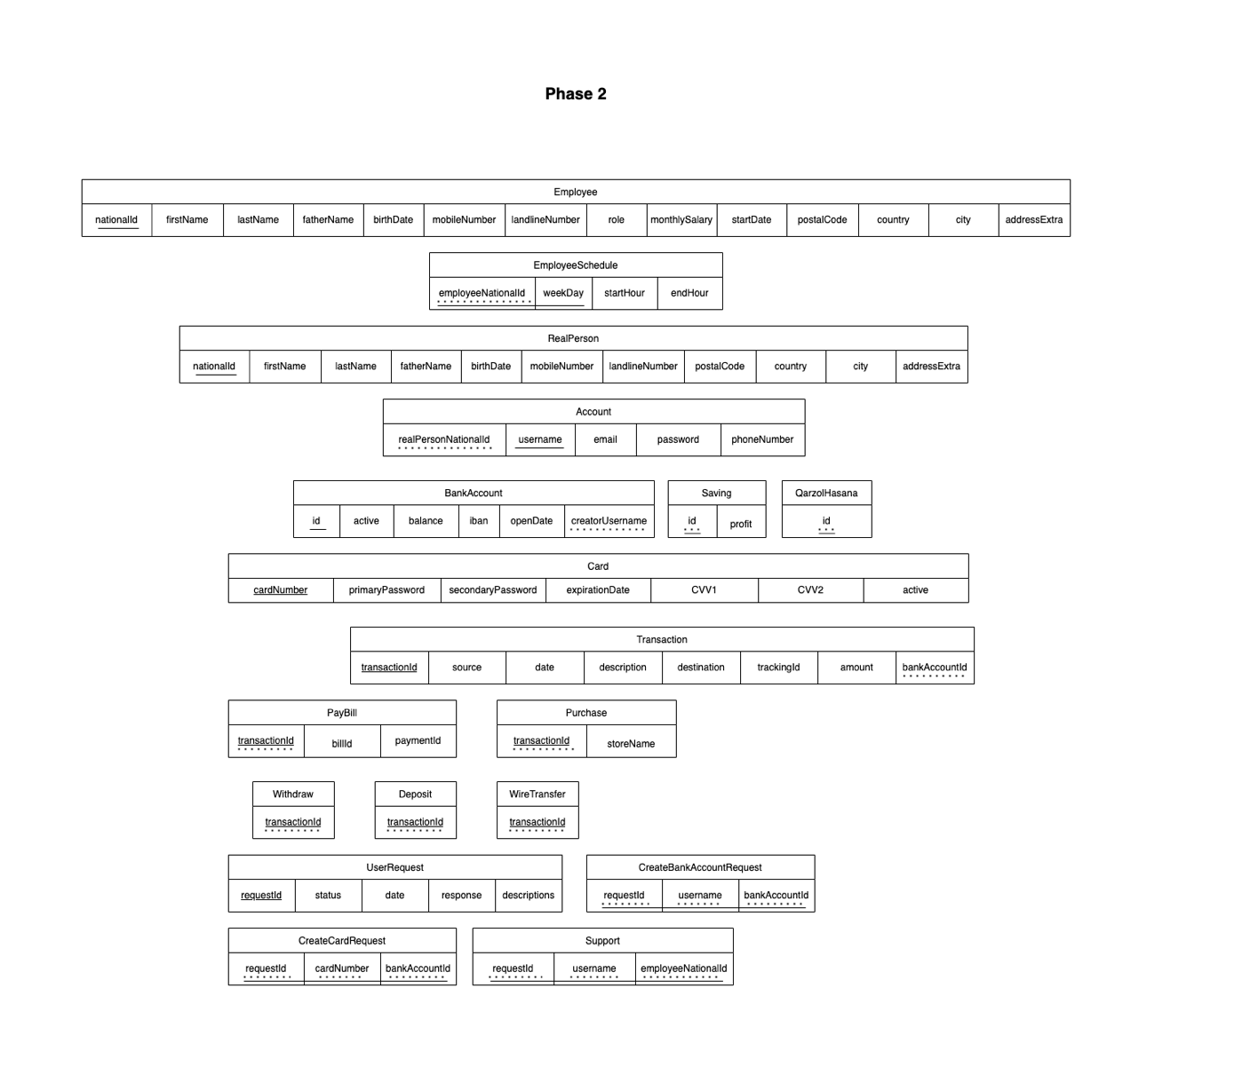

حال دامنه صفات هر یک از جدول‌ها را به دست می‌آوریم. داریم:

* Employee
  + nationalId: 10-digit number can start with 0 (string fix length: 10)
  + firstName: string (maximum length: 30)
  + lastName: string (maximum length: 30)
  + fatherName: string (maximum length: 30)
  + birthDate: date object (more than 18 years)
  + mobileNumber: 10-digit number can start with 0 (string fix length: 10)
  + landlineNumber: 10-digit number can start with 0 (string max length: 10)
  + role: text
  + monthlySalary: money object
  + startDate: date object
  + postalCode: 10-digit number can start with 0 (string fix length: 10)
  + country: string (maximum length: 50)
  + city: string (maximum length: 50)
  + addressExtra: text
* EmployeeSchedule:
  + employeeNationalId: 10-digit number can start with 0 (string fix length: 10)
  + weekDay: custom weekday enum type (defined in the database)
  + startHour: time data type
  + endHour: time data type
* RealPerson:
  + nationalId: 10-digit number can start with 0 (string fix length: 10)
  + firstName: string (maximum length: 30)
  + lastName: string (maximum length: 30)
  + fatherName: string (maximum length: 30)
  + birthDate: date object (more than 18 years)
  + mobileNumber: 10-digit number can start with 0 (string fix length: 10)
  + landlineNumber: 10-digit number can start with 0 (string max length: 10)
  + postalCode: 10-digit number can start with 0 (string fix length: 10)
  + country: string (maximum length: 50)
  + city: string (maximum length: 50)
  + addressExtra: text
* BankAccount:
  + id: serial
  + active: boolean
  + balance: money
  + iban: 24-digit number (string fix length: 24)
  + openDate: date data type
  + creatorUsername: string (maximum length: 30)
* Saving:
  + id: integer
  + profit: real (between 0 and 1)
* QarzolHasana:
  + id: integer
* PayBill:
  + transactionId: bigint
  + billId: string (maximum length: 13)
  + paymentId: string (maximum length: 13)
* Purchase:
  + transactionId: bigint
  + storeName: string (maximum length: 100)
* Withdraw:
  + transactionId: bigint
* Deposit:
  + transactionId: bigint
* WireTransfer:
  + transactionId: bigint
* Account:
  + realPersonNationId: 10-digit number can start with 0 (string fix length: 10)
  + username: string (maximum length: 30)
  + email: string (maximum length: 50)
  + password: SHA-256 hash (string fix length: 32)
  + phoneNumber: 10-digit number can start with 0 (string fix length: 10)
* Card:
  + cardNumber: string (maximum length: 19)
  + primaryPassword: SHA-256 hash (string fix length: 32)
  + secondaryPassword: SHA-256 hash (string fix length: 32)
  + expirationDate: date
  + CVV1: string (maximum length: 4)
  + CVV2: string (maximum length: 4)
  + active: boolean
  + bankAccount: integer
* Transaction:
  + transactionId: bigserial
  + source: integer
  + destination: integer
  + date: date
  + description: text
  + trackingId: bigserial
  + amount: money
* CreateCardRequest:
  + requestId: bigint
  + bankAccountId: integer
* Support:
  + requestId: bigint
  + username: string (maximum length 30)
  + employeeNationalId: 10-digit number can start with 0 (string fix length: 10)
* UserRequest:
  + requestId: bigserial
  + status: custom status enum type (defined in the database)
  + date: date
  + response: text
  + description: text
* CreateBankAccountRequest:
  + requestId: bigint
  + username: string (maximum length 30)
  + bankAccountType: custom bank account type enum (defined in the database)

Database

CREATE TABLE Employee (

nationalId char(10),

firstName varchar(30),

lastName varchar(30),

fatherName varchar(30),

birthDate date,

mobileNumber char(10),

landlineNumber char(10),

empRole text,

monthlySalary numeric,

startDate date,

postalCode char(10),

country varchar(30),

city varchar(30),

addresExtra text,

PRIMARY KEY(nationalId)

);

CREATE TABLE EmployeeSchedule (

emplyeeNationalId char(10),

weekDay varchar(10),

startHour time,

endHour time,

PRIMARY KEY(emplyeeNationalId, weekDay),

FOREIGN KEY(emplyeeNationalId) REFERENCES Employee(nationalId)

);

CREATE TABLE RealPerson (

nationalId char(10),

firstName varchar(30),

lastName varchar(30),

fatherName varchar(30),

birthDate date,

mobileNumber char(10),

landlineNumber char(10),

postalCode char(10),

country varchar(30),

city varchar(30),

addresExtra text,

PRIMARY KEY(nationalId)

);

CREATE TABLE Account (

realPersonNationalId char(10),

username varchar(30),

email text,

accountPassword varchar(30),

phoneNumber char(10),

PRIMARY KEY(username),

FOREIGN KEY(realPersonNationalId) REFERENCES RealPerson(nationalId)

);

CREATE TABLE Account (

    realPersonNationId: CHAR(10),

    username: VARCHAR(30),

    email: VARCHAR(30),

    password: VARCHAR(30),

    phoneNumber: CHAR(10)

)

CREATE TABLE BankAccount (

    id: VARCHAR(13)

    active: BOOLEAN

    balance: NUMRIC

    iban: CHAR(24)

    openDate: Date

    creatorUsername: VARCHAR(30)

)

CREATE TABLE QarzolHasana (

    id: VARCHAR(13)

)

CREATE TABLE Saving (

    id:VARCHAR(13)

    profit: NUMERIC

)

CREATE TABLE Card (

    cardNumber: VARCHAR(19),

    primaryPassword: CHAR(4),

    secondaryPassword: CHAR(8),

    expirationDate: DATE,

    CVV1: VARCHAR(4),

    CVV2: VARCHAR(4),

    active: BOOLEAN

)

CREATE TABLE Transaction (

    transitionId: CHAR(10),

    source: bigint (16-19 digit),

    destination: bigint (16-19 digit),

    date: DATE,

    description: TEXT,

    trackingId: INT

    amount: NUMRIC,

    trackingId: NUMRIC

)

CREATE TABLE Purchase (

    transactionId: NUMRIC

    storeName: VARCHAR(50)

)

CREATE TABLE PayBill (

    transactionId: NUMRIC

    billId: NUMRIC

    paymentId: NUMRIC

)

CREATE TABLE WireTransfer (

    transactionId: NUMRIC

)

CREATE TABLE Deposit (

    transactionId: NUMRIC

)

CREATE TABLE Withdraw (

    transactionId: NUMRIC

)

CREATE TABLE UserRequest (

    requestId: INT,

    status: CHAR(3),

    date: DATE,

    response: TEXT,

    description: TEXT

)

CREATE TABLE CreateBankAccountRequest (

    requestId: INT,

    username:  VARCHAR(30),

    bankAccount: NUMRIC

)

CREATE TABLE CreateCardRequest (

    requestId: INT,

    cardNumber: VARCHAR(30),

    bankAccountId: VARCHAR(13)

)

CREATE TABLE Support (

    requestId: INT,

    username: VARCHAR(30),

    employeeNationId: CHAR(10)

)